**Kinovea vibration trigger research**

Turned out this method is overly complex.  All I needed to do was use the SW-420 vibration switch by itself across the microphone input cord.  The DC voltage supplied by the microphone input is sufficient to trigger a “loud” sound by just shorting (or unshorting) the connection.

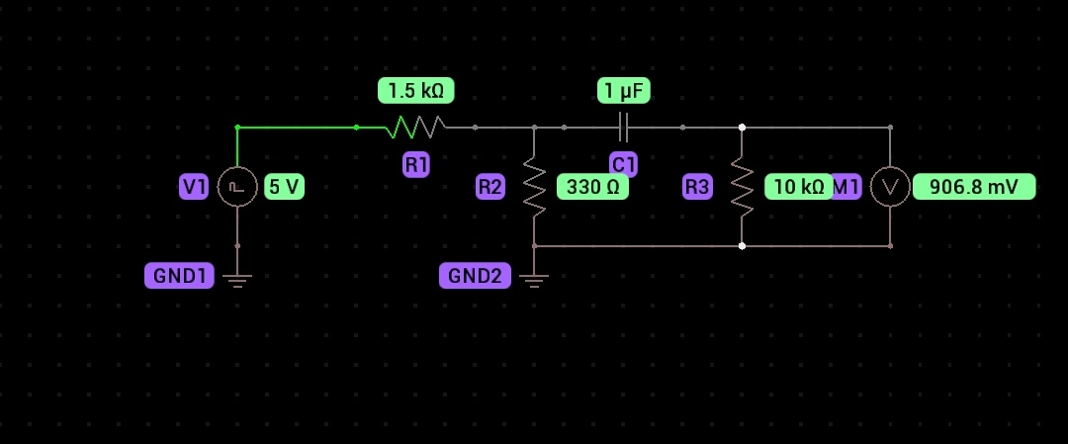

V1 in the above is actually a SW-420 vibration switch module with sensitivity setting and digital output.

The voltmeter on the right of the circuit is the output which needs to connect to the pc through a TRS connector.

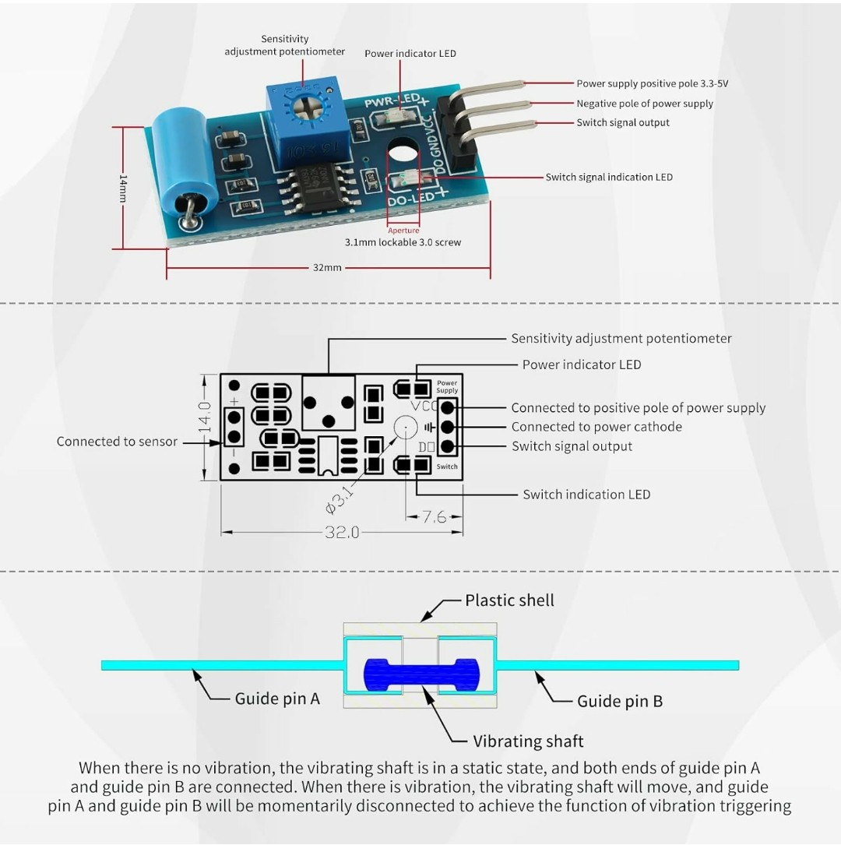

Vcc input to the device is 5v from a usb connector.

Output connects to a TRS connector per the diagram below.

